Data Source Configuration :

Take the IP of DB box and Appserver box using ip config and ifconfig

Windows Box :

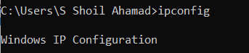

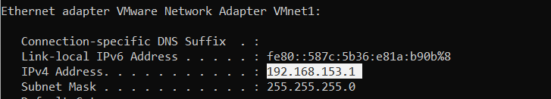

Linux Box:



Check the connectivity between two boxes using ping

Linux Box to windows Box :

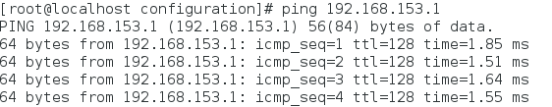

Windows Box to linux box :

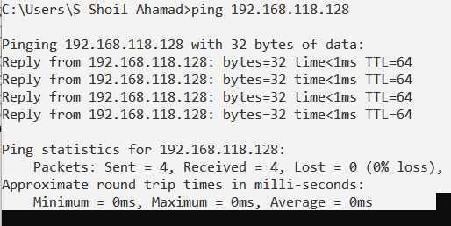

As both boxes have connectivity we will proceed further for creating the data source .

Download the ojdbc6.jar file .

Now login to the admin console using the url : http://192.168.118.128 :9990/console

Goto Deployment section and Add this ojdbc6.jar file

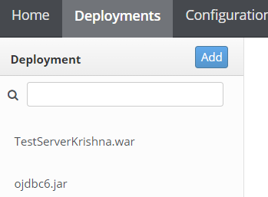

Now Goto configuration🡪 Subsystems🡪Datasources 🡪 Select Non-XA and click on Add .

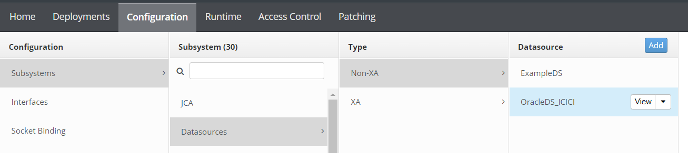

Select Oracle Database

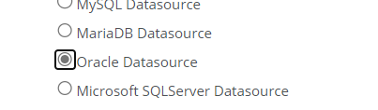

Note : if we are implementing Datasource for other Databases like DB2,Postgres etc., jar files will change and while selecting select the appropriate database .

Provide the Datasourcename and JNDI name as below as per your customized names.

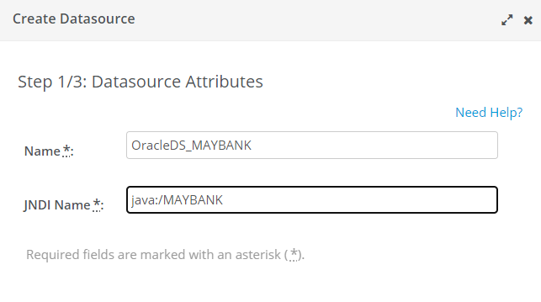

Click on Next .

Goto Detected Driver .

Select the ojdbc6.jar file which you deployed .

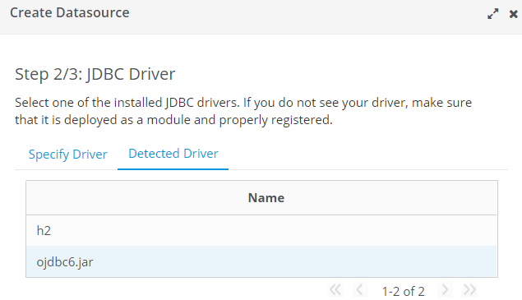

Click on Next.

Provide the connection url , IP will change as per your box ip .

Oracle username and password

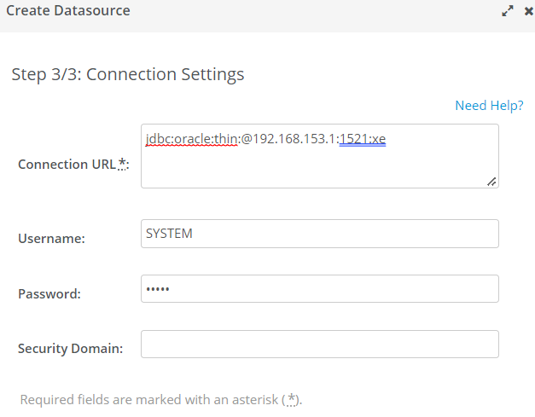

Click on Next .

Default Username : SYSTEM , password =Admin.

Click on Next .

After this we will Test whether the data source is connected or not by clicking on

TestConnection Button

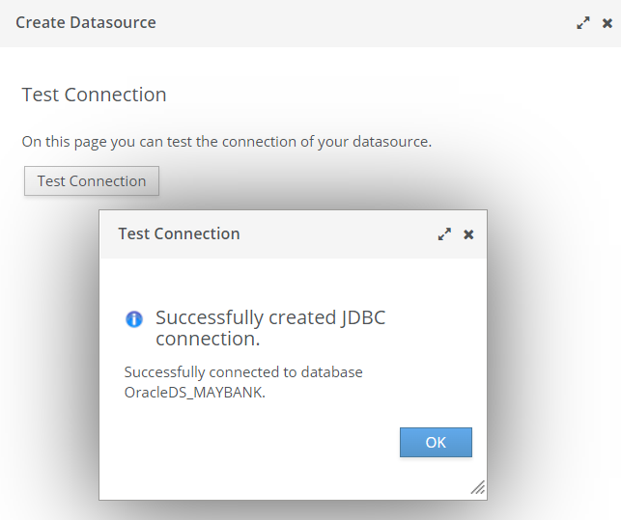

If Test connection is successful Then we are done . Click on Next.

Once it is done we will see the final message as below

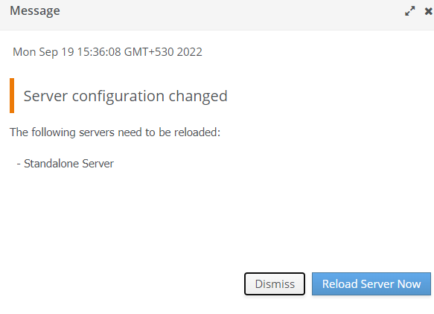

JBOSS-Cli commands for creating the Datasources :

1. Connect to the Jboss-cli using jboss-cli.sh sctipt and connect to the management console as below



Go to the location /opt/jboss-eap-7.1/modules/system/layers/base/com

1. Create the folders : oracle/main

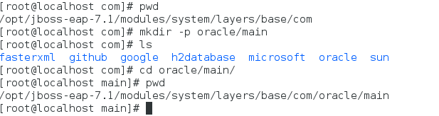

1. Load the jar files to the modules directory under

EAP-Home/modules/system/layers/base/com/oracle/main

1. Deploy the ojdbc6.jar using the command
2. Run the below command to add the ojdbc6.jar file in the modules folder. Add the Oracle JDBC driver as a core module.

module add --name=com.oracle --resources=/path to ojdbc6.jar --dependencies=javax.api,javax.transaction.api



1. Load the driver in the xml file using the below command . Register the Oracle JDBC driver.

/subsystem=datasources/jdbc-driver=oracle:add(driver-name=oracle,driver-module-name=com.oracle)

1. Add the Oracle datasource.

data-source add --name=OracleDS_MAYBANK --jndi-name=java:jboss/OracleDS_MAYBANK --driver-name=oracle --connection-url=jdbc:oracle:thin:@OracleBoxIP:1521:XE --user-name=admin --password=admin

1. To check whether the datasource is able to connect to the database, run the following command:

/subsystem=datasources/data-source=books-datasource:test-connection-in-pool